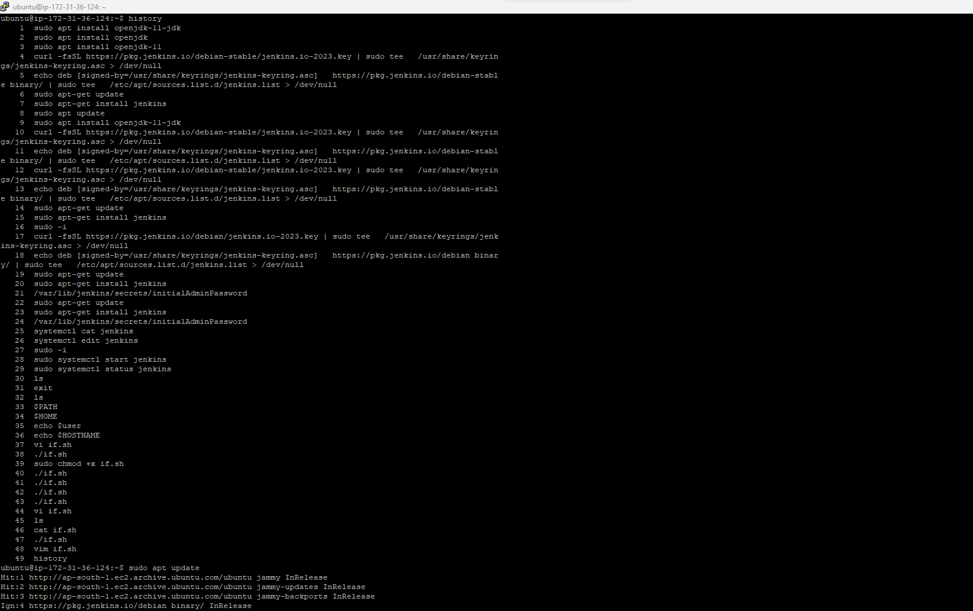

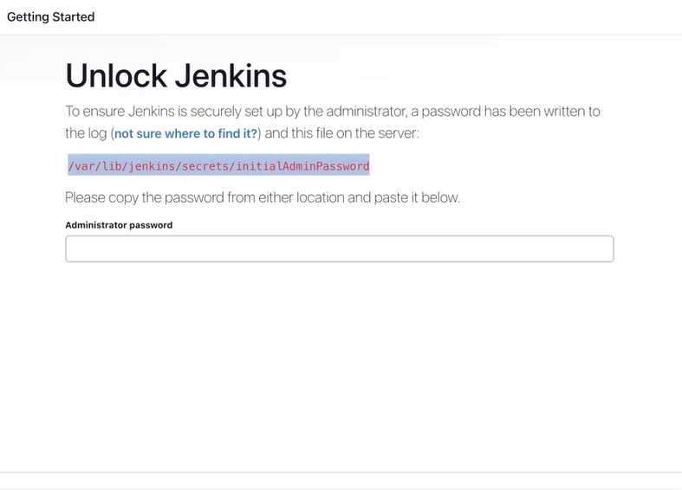

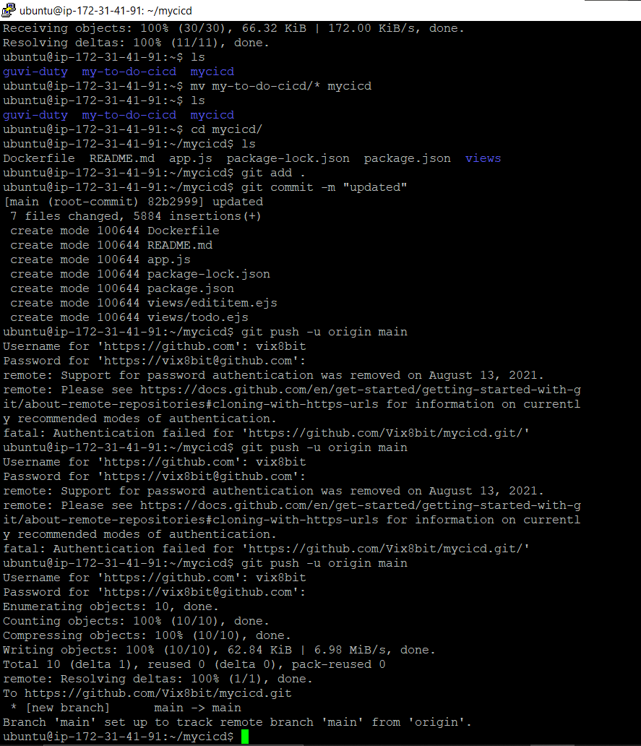

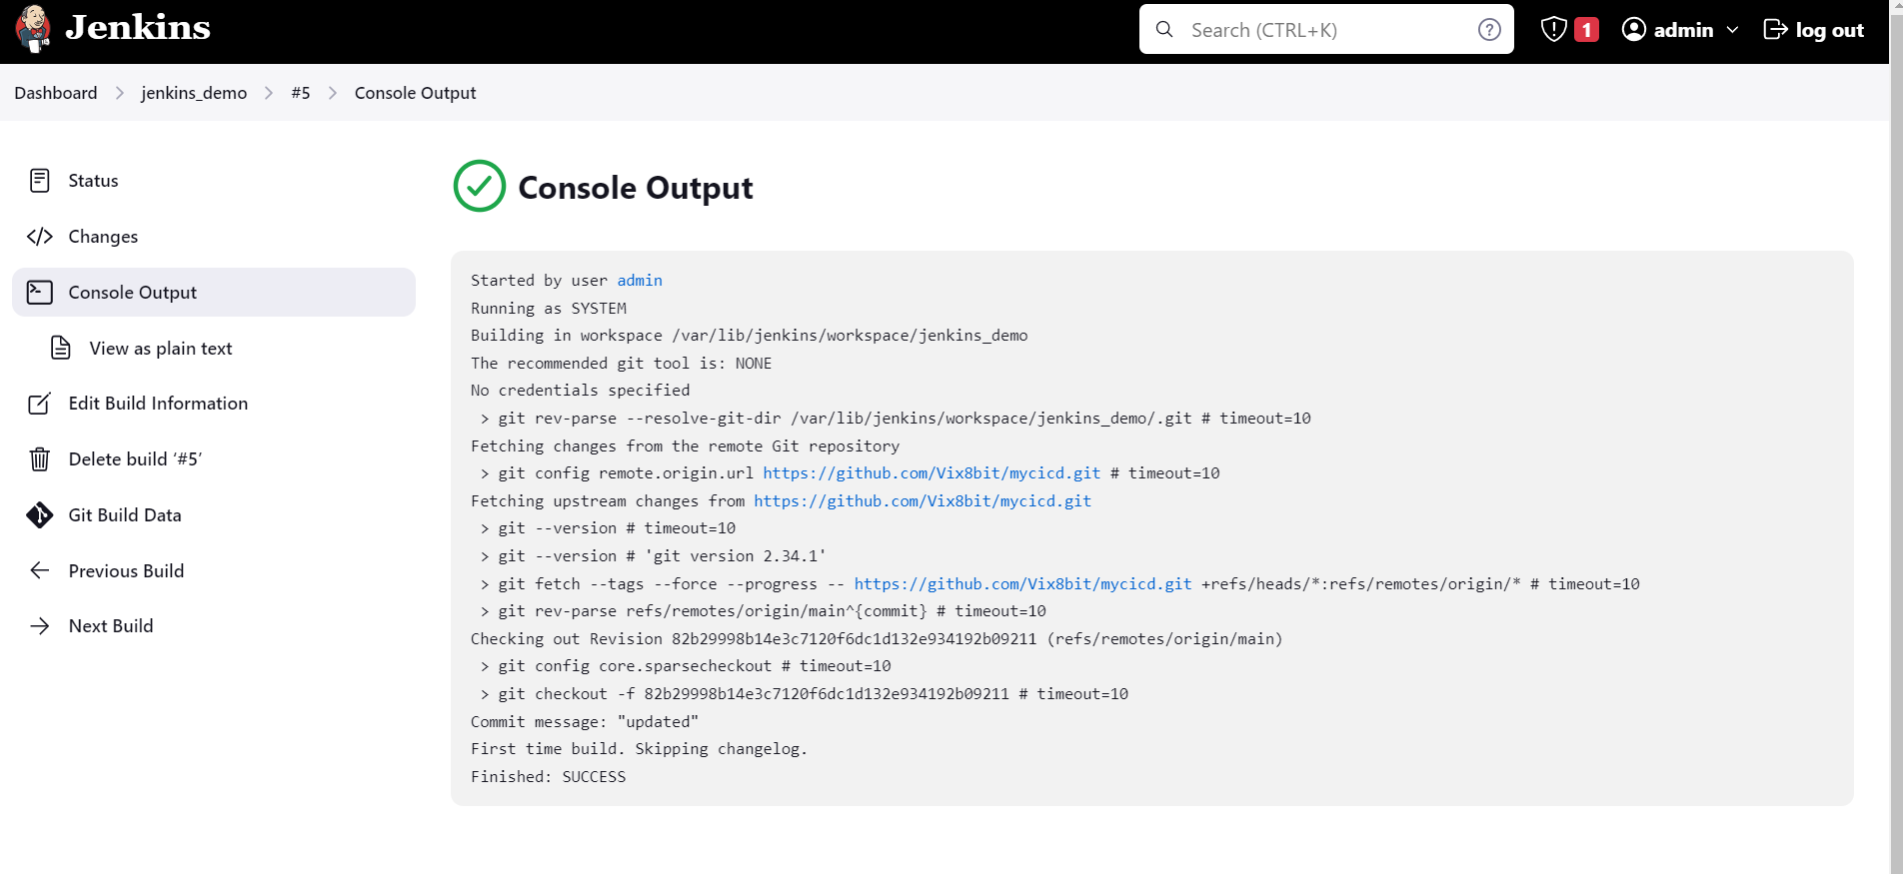

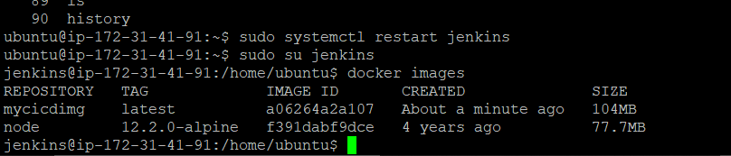

Started by an SCM change

Running as SYSTEM

Building in workspace /var/lib/jenkins/workspace/jenkins_demo

The recommended git tool is: NONE

No credentials specified

> git rev-parse --resolve-git-dir /var/lib/jenkins/workspace/jenkins_demo/.git # timeout=10

Fetching changes from the remote Git repository

> git config remote.origin.url <https://github.com/Vix8bit/mycicd.git> # timeout=10

Fetching upstream changes from <https://github.com/Vix8bit/mycicd.git>

> git --version # timeout=10

> git --version # 'git version 2.34.1'

> git fetch --tags --force --progress -- <https://github.com/Vix8bit/mycicd.git> +refs/heads/*:refs/remotes/origin/* # timeout=10

> git rev-parse refs/remotes/origin/main^{commit} # timeout=10

Checking out Revision 281c1a2b69788917a9bfc91e3763c12cfe2a786a (refs/remotes/origin/main)

> git config core.sparsecheckout # timeout=10

> git checkout -f 281c1a2b69788917a9bfc91e3763c12cfe2a786a # timeout=10

Commit message: "Update todo.ejs"

> git rev-list --no-walk ad4082d68ba109f6efdc89f7c2437cb0387ed338 # timeout=10

[jenkins_demo] $ /bin/sh -xe /tmp/jenkins4068052316428139250.sh

+ docker build -t mycicdimg .

DEPRECATED: The legacy builder is deprecated and will be removed in a future release.

Install the buildx component to build images with BuildKit:

<https://docs.docker.com/go/buildx/>

Sending build context to Docker daemon 392.2kB

Step 1/6 : FROM node:12.2.0-alpine

---> f391dabf9dce

Step 2/6 : WORKDIR app

---> Using cache

---> a4b40808e5d5

Step 3/6 : COPY . .

---> 776b2d823307

Step 4/6 : RUN npm install

---> Running in e831c65286c0

[91mnpm[0m[91m WARN read-shrinkwrap This version of npm is compatible with lockfileVersion@1, but package-lock.json was generated for lockfileVersion@2. I'll try to do my best with it!

[0m

> ejs@2.7.4 postinstall /app/node_modules/ejs

> node ./postinstall.js

Thank you for installing [35mEJS[0m: built with the [32mJake[0m JavaScript build tool ([32mhttps://jakejs.com/[0m)

[91mnpm[0m[91m [0m[91mWARN[0m[91m my-todolist@0.1.0 No repository field.

[0m[91mnpm WARN my-todolist@0.1.0 No license field.

[0m[91m

[0madded 291 packages from 653 contributors and audited 291 packages in 8.167s

found 14 vulnerabilities (6 moderate, 6 high, 2 critical)

run `npm audit fix` to fix them, or `npm audit` for details

Removing intermediate container e831c65286c0

---> 8f093b646172

Step 5/6 : EXPOSE 8000

---> Running in 10d7f9a2f227

Removing intermediate container 10d7f9a2f227

---> 2d5fe1780ced

Step 6/6 : CMD ["node","app.js"]

---> Running in e706559c39cb

Removing intermediate container e706559c39cb

---> 3df05fc8554c

Successfully built 3df05fc8554c

Successfully tagged mycicdimg:latest

+ docker stop mycicdcont

mycicdcont

+ docker rm mycicdcont

mycicdcont

+ docker run -d --name mycicdcont -p 8000:8000 mycicdimg

6805be686702f92c1168efc6916be3733ce2ecfd68b1e6ded1cf9af4f26b9a3e

Finished: SUCCESS

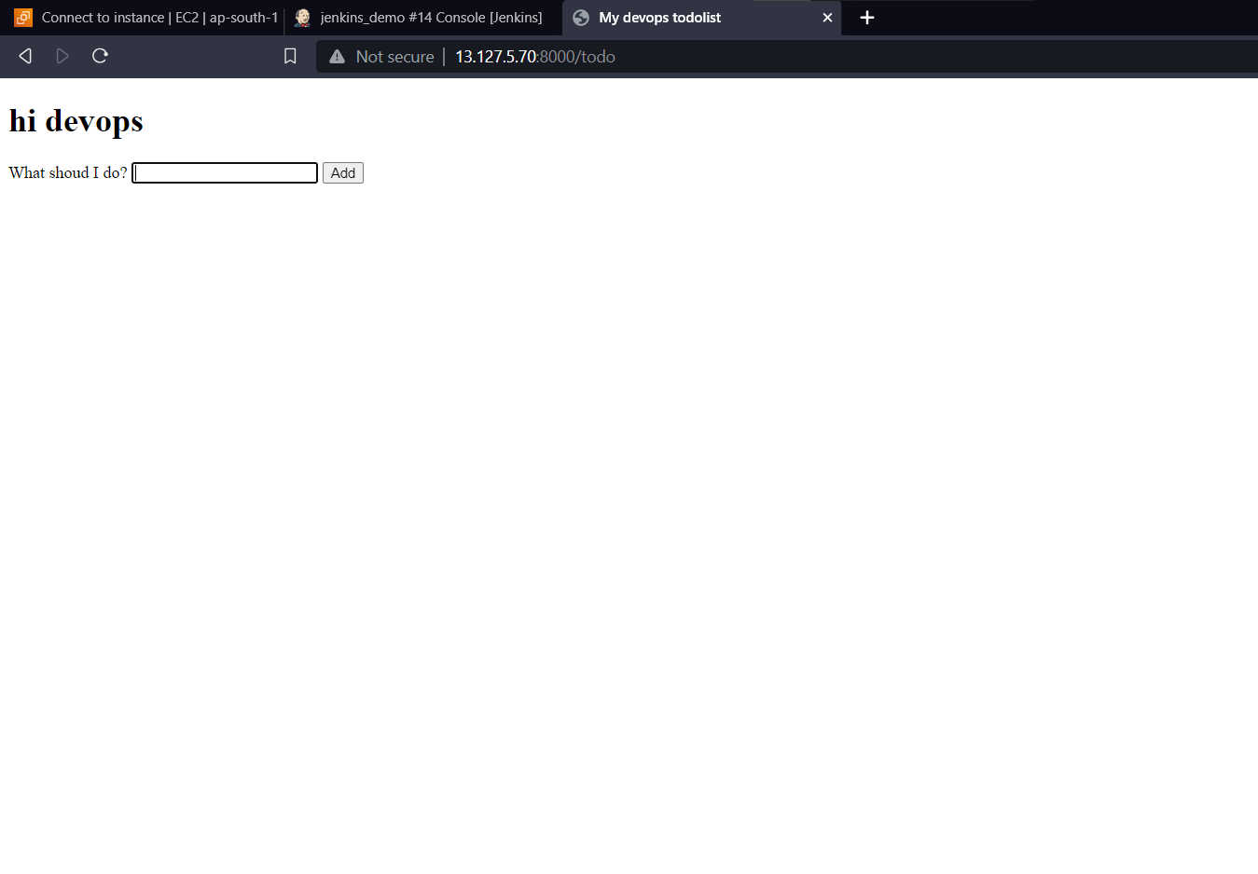

Build trigger

